1. Centos
   1. Create a Virtual Machine
      1. Some options for Virtual Machines can be VirtualBox for VMWare
      2. I will be using VirtualBox this can be downloaded here: <https://www.virtualbox.org/wiki/Downloads>
      3. Go ahead and click through the download process until you come to end
   2. Downloading the OS
      1. Centos ISO file can be downloaded here: <https://mirrors.mit.edu/centos/7.9.2009/isos/x86_64/>
      2. See screenshot below for reference on which download you will need from the list in the link:

* 1. Creating the Virtual Machine
     1. Find the ISO file you just downloaded
     2. You are going to launch VirtualBox if you haven’t already
     3. You are going to select “New” at the upper right corner of VirtualBox (use the screenshot below for reference) A screenshot of a computer

        Description automatically generated
     4. Name your Virtual Machine whatever you would like. I perfer naming it based off the OS (reference screenshot in set 5)
     5. Under “ISO Image” please find your Centos ISO file based off the location we found it at in set 1 (reference screenshot below) A screenshot of a computer

        Description automatically generated
     6. Hit next
     7. You will be prompt with options for hardware. Keep them as default and hit next
     8. You will be prompted with options for memory allocation. Keep them as default and hit next
     9. Finally you want to make sure you network is switched from NAT to Bridged (this will help us down the road for file share)
     10. Highlight your server by clicking on it once
     11. On the right hand side find network and click on itA screenshot of a computer

         Description automatically generated
     12. Once open go to the drop down menu for “Attached to:” and select “Bridged Adapter”

* + 1. Click okay and you’re ready to go!
  1. Setting up your system (some of these steps may take a few moments to proper load and set up for warning)
     1. Now that you have Centos in your VirtualBox you need to launch it and set up for use
     2. You can double click your server on the left side of VirtualBox to launch it
     3. You’re going to be prompted to a CentOS boot screen from here select “Test this media & install CentOS 7” (reference my screenshot below)A screenshot of a computer

        Description automatically generated
     4. After the following step has completed you will now set up the basics of the machine
     5. In the installation summary you will notice a warning under “System” on the “Installation Location”
     6. Please click on “Installation Location”
     7. You want to click and select the hard drive for the Virtual Machine and click done in upper left (reference my screenshot below)

* + 1. Now you’re back at “System Summary”. Click “Begin Installation” in the lower left corner
    2. You are now going to set a root password. Select this option and set your password to SOMETHING YOU WILL REMEMBER (maybe write this down you don’t want to forget it)
    3. Click “Done” in the upper left corner
    4. Now you will create a user. Select this option and fill in all that is blank (Full name and password)
    5. Before continuing please check off “Make this user administrator” (see screenshot for reference)

* + 1. Click done and continue the installation. The installation will take some time
    2. Once completed you will be prompted to reboot
    3. You can now log into Centos with the username and password you created!
  1. Checking the internet connection
     1. Make sure you’re logged in and are on the terminal page you were launched onto
     2. Type the command *ping* [*www.google.com*](http://www.google.com)
        + If results are good it should look like this: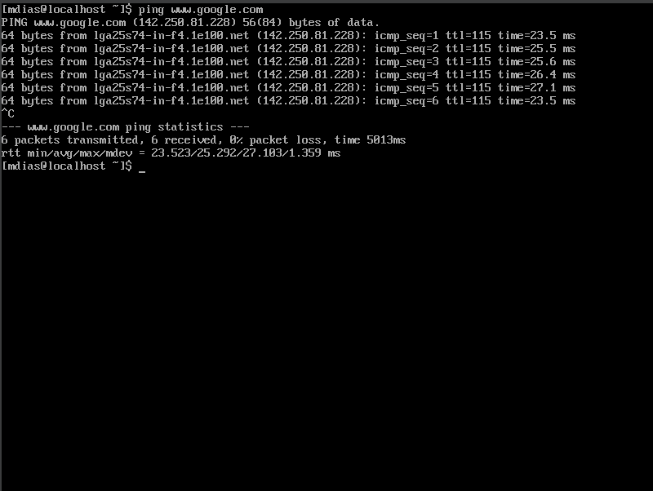
        + If you’re having issues pinging I found a great breakdown for a permanent fix. Please reference this link as it is a step-by-step visual breakdown on how to fix this: <https://www.youtube.com/watch?v=IxookDRgOZM&ab_channel=Tutorials4urHelp> (Jump to timestamp 2:50 for the permanent solution)
  2. Setting up file sharing
     1. You want to make a text file we can use to test our file share
     2. Go to notepad on Windows and create a file and save it your desktop as “testing” (or whatever you’d like but I will be using testing)
     3. Now you want to open your Command Prompt
     4. To test if SCP is already set up type the command *scp*
        + If its already set up it should look like this*A screen shot of a computer

          Description automatically generated*
        + If this did not work, follow the next sets if it did continue to step 5
        + On your Windows Search bar on your taskbar look up “Optional Features”
        + Open this and at the top of the page click on “View Features” under “Add an optional feature”
        + Scroll down until you find “OpenSSH Client” select this hit next
        + Once install go back and try the command again
     5. Now move back to your Centos machine so you can find your IP address
     6. Type in the command *ifconfig* (below are the results, the highlighted portion is your IP address

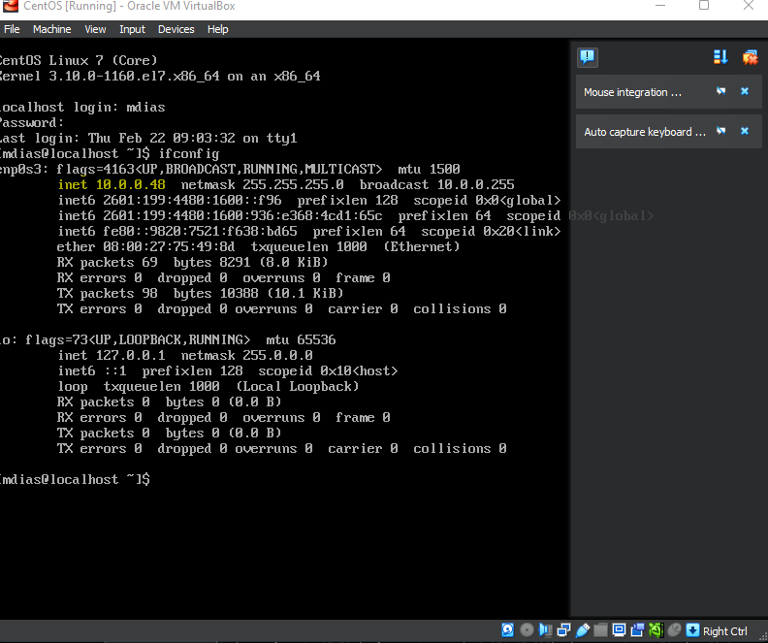

* + - * If this did not work you may need to install net-tools
      * Type the command *sudo yum install epel-release*
      * Type the command *sudo yum install net-tools*
      * Now try *ifconfig* again!
    1. Now go back to your Command Prompt in Windows and we will send our file over
    2. Type the following command: *scp C:\Users\YOUR WINDOWS NAME\Desktop\YOUR FILE.txt YOUR LINUX USER@YOUR LINUX IP ADDRESS:/home/YOUR LINUX USER/*
       - Mine looks like this: *scp C:\Users\mattd\Desktop\testing.txt* [*mdias@10.0.0.70:/home/mdias/*](mailto:mdias@10.0.0.70:/home/mdias/)
    3. Now type in Linux Password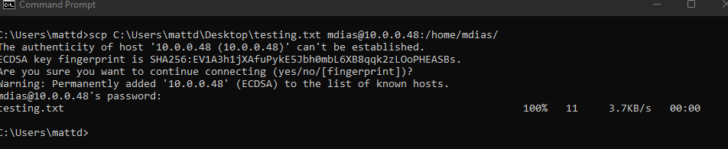
    4. Now go back to you Centos machine and make sure the file successfully made it over
    5. Type the command *ls*

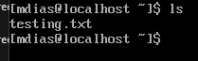

1. Ubuntu Server
   1. Create a Virtual Machine
      1. Some options for Virtual Machines can be VirtualBox for VMWare
      2. I will be using VirtualBox this can be downloaded here: <https://www.virtualbox.org/wiki/Downloads>
      3. Go ahead and click through the download process until you come to end
   2. Downloading the OS
      1. Ubuntu ISO file can be downloaded here:
      2. See screenshot below for reference on which download you will need from the list in the link: <https://ubuntu.com/download/server>
   3. Creating the Virtual Machine
      1. Find the ISO file you just downloaded
      2. You are going to launch VirtualBox if you haven’t already
      3. You are going to select “New” at the upper right corner of VirtualBox (use the screenshot below for reference) A screenshot of a computer

         Description automatically generated
      4. Name your Virtual Machine whatever you would like. I perfer naming it based off the OS (reference screenshot in set 5)
      5. Under “ISO Image” please find your Ubuntu ISO file based off the location we found it at in set 1 (reference screenshot below) A screenshot of a computer

         Description automatically generated
      6. Hit next
      7. You will be prompt with options for hardware. Keep them as default and hit next
      8. You will be prompted with options for memory allocation. Keep them as default and hit next
      9. Finally you want to make sure you network is switched from NAT to Bridged (this will help us down the road for file share)
      10. Highlight your server by clicking on it once
      11. On the right hand side find network and click on it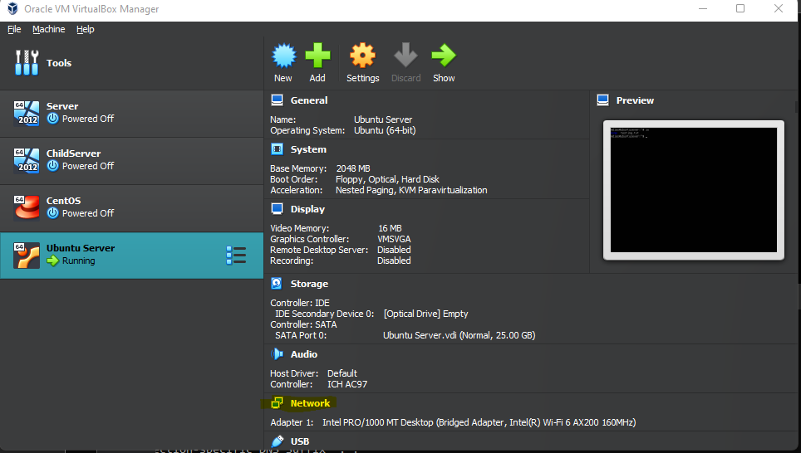
      12. Once open go to the drop down menu for “Attached to:” and select “Bridged Adapter”

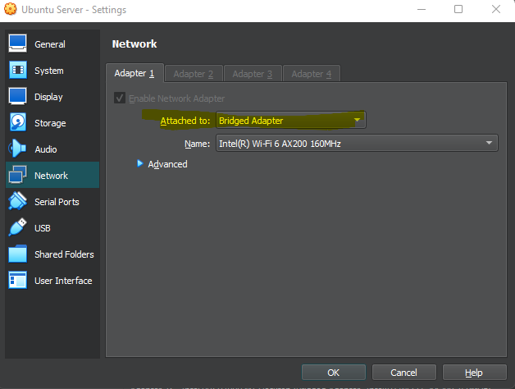

* + 1. Click okay and you’re ready to go!
  1. Setting up your system (some of these steps may take a few moments to proper load and set up for warning)
     1. Now that you have Ubuntu Sever in your VirtualBox you need to launch it and set up for use
     2. You can double click your server on the left side of VirtualBox to launch it
     3. You will be prompted to select a language. Pick your preferred option
        + If updates are required this will be the next prompted screen. PLEASE UPDATE IF NECESSARY
     4. You will now be prompted to select the keyboard layout you use. Pick your preferred keyboard layout
     5. Make sure you select “Install the Ubuntu Sever” if it is not already selected and hit continue
     6. The network will not set up and give you option for a proxy server. You can go ahead and continue past this once the network has completed setting up
     7. You will continue on until you hit the page for creating a username and password
     8. Please set these up now
     9. Continue through the next few pages until you are prompted with setting up SSH. I recommend having this set up for later
     10. You can now continue all the way to reboot
     11. Once rebooted enter the username and password you created!
  2. Checking internet connection
     1. Make sure you’re logged in and are on the terminal page you were launched onto
     2. Type the command *ping* [*www.google.com*](http://www.google.com)
     3. The results should look like the followingA screenshot of a computer screen

        Description automatically generated
     4. Ubuntu should have already had the network connection set up. If you’re having issues with pinging ensure you’re typing the right command and are connected to the internet
  3. Setting up file share using SCP
     1. You want to make a text file we can use to test our file share
     2. Go to notepad on Windows and create a file and save it your desktop as “testing” (or whatever you’d like but I will be using testing)
     3. Now you want to open your Command Prompt
     4. To test if SCP is already set up type the command *scp*
        + If its already set up it should look like this*A screen shot of a computer

          Description automatically generated*
        + If this did not work, follow the next sets if it did continue to step 5
        + On your Windows Search bar on your taskbar look up “Optional Features”
        + Open this and at the top of the page click on “View Features” under “Add an optional feature”
        + Scroll down until you find “OpenSSH Client” select this hit next
        + Once install go back and try the command again
     5. Now move back to your Ubuntu machine so you can find your IP address
     6. Type in the command *ifconfig* (below are the results, the highlighted portion is your IP address

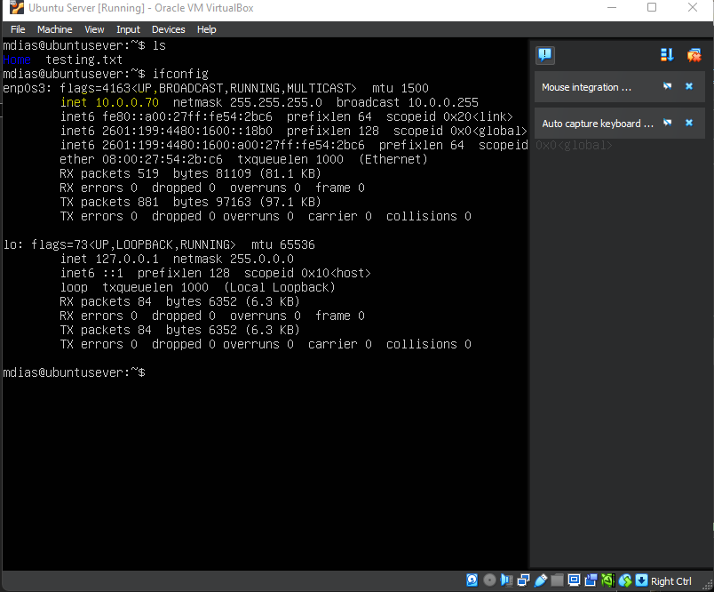

* + - * If this did not work you may need to install net-tools
      * Type the command *sudo apt install net-tools*
      * Now try *ifconfig* again!
    1. Now go back to your Command Prompt in Windows and we will send our file over
    2. Type the following command: *scp C:\Users\YOUR WINDOWS NAME\Desktop\YOUR FILE.txt YOUR LINUX USER@YOUR LINUX IP ADDRESS:/home/YOUR LINUX USER/*
       - Mine looks like this: *scp C:\Users\mattd\Desktop\testing.txt* [*mdias@10.0.0.70:/home/mdias/*](mailto:mdias@10.0.0.70:/home/mdias/)
    3. Now type in Linux Password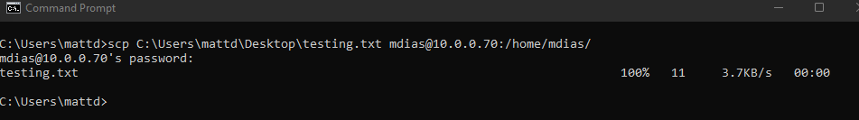
    4. Now go back to you Ubuntu machine and make sure the file successfully made it over
    5. Type the command *ls*

